P235/1
ISLAMIC
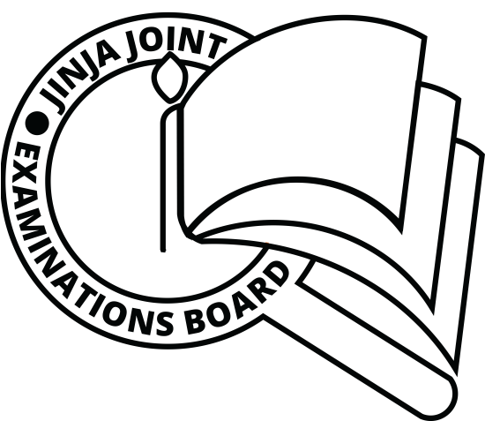
RELIGIOUS
EDUCATION
Paper 1
THE HOLY QUR’AN
AUGUST, 2019
2½ hours

JINJA JOINT EXAMINATIONS BOARD
Uganda Advanced Certificate of Education
MOCK EXAMINATIONS – AUGUST, 2019
ISLAMIC RELIGIOUS EDUCATION
THE HOLY QUR’AN

Paper 1

2 hours 30 minutes

INSTRUCTIONS TO CANDIDATES:

Answer any FOUR questions.

ALL questions carry equal marks.

1. ”Surely if Mankind and Jinns were to get together to produce the like of this Quran, they will never be able to produce the like of it “17:88
How far does the above verse reflect the miraculous nature of the Quran (25 marks)
2. With evidence from the Holy Quran and Hadith, prove that life in hell will be very different from that in paradise (25 marks)
3. According to chapter 112, monotheism is taken to constitute one third of the Quran. Explain the verse and analyze other themes of the Quran (25 marks)
4. The Quran gives an account of individuals and communities that were punished for disobeying god. Comment (25 marks)
5. (a) God says “if your divorced wives breast feed the children for you pay for their services”65:6
Examine the implication of this verse, and others that recognize the rights of divorced wives. (12 marks)
(b) Discuss the various types of ending marital relationship and explain why God put such conditions in place? (13marks)
6 . Examine the major principles governing the Islamic economic system. (25 marks)
7. Explain the Quran guidance on the way how workers should be treated. (25 marks)
8. Discuss the Quranic teaching on the practice of Ribah and why was it abolished?
(25 marks)
9. Examine the ways how Islamic Jihad differs from the act of terrorism. (25 marks)
10. Discuss the Quranic teachings on international relations. (25 marks)
11. (a) Analyse the content of Surat Kauthara. (12 marks)
(b) Give the lessons got from the above Surah. (13 marks)
12. (a) Analyse the content of surat al-tiin (13 marks)
(b) How is the message beneficial to the Muslims? (12 marks)

